About System.

This system is mainly created for Bar & Restaurants where simultaneously various bills are being created. The system supports creation up to 26 bills at same time. The billing window of this system contains 26 table/cabin buttons, and you can create bill for your each table/cabin.

Billing Window

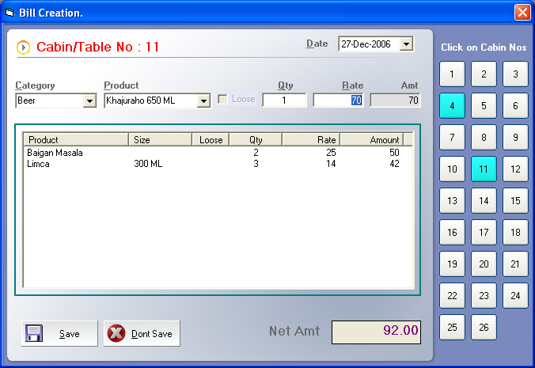

For every table or cabin of your restaurant there is a table/cabin button on right side of billing widow. Simply press the table button and create bill for that table.

On above screen you’ll find that simultaneously two bills are being created for Table no 4 and Table no 11

Billing Monitor.

The system supports a 'Billing Monitor' that shows recently created but unpaid bills.

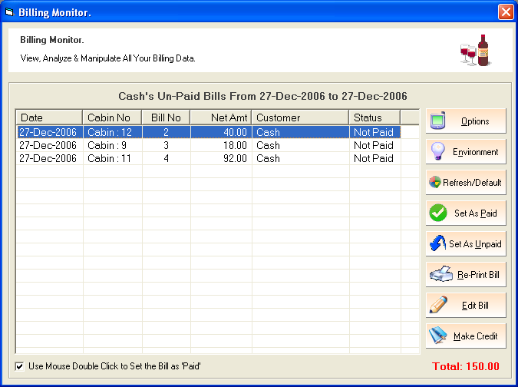

Above window is most powerful tool of this application. User can find all created bills at this window. Every bill created at billing window automatically adds to this window. When you receive payment of same bill just select the bill and click on ‘Set as Paid’ button.

Click on ‘Options’ button will give you various options to filter the bills showing in billing monitor, ‘Environment’ button provides option to set the display environment, user can ‘Edit’ , ‘Re-Print’ a bill.

User can transfer a bill to any customers account also.
Ms Agent

There is Agent ‘Merlin’ for your convenience that will guide you on every stage of operation.

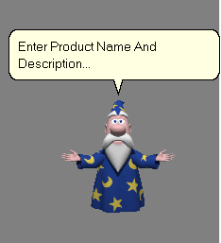

If you do not need this simply click on ‘View’ menu and ‘Agent’ option the ‘merlin’ will get invisible.

Along with this the system contains various useful features. Just run the application and enjoy.

About Author.

System : Restaurant & Bar Management System.
Author : Haresh Eshwarlal Jaiswal.
Organization : Rising Technologies, Jalna. (Maharashtra)
E-Mail : Haresh_Jaiswal@Rediffmail.com

Phone : 02482 - 240212
Mobile : 9423156065

If you have any suggestions please mail me at

Haresh_Jaiswal@Rediffmail.com

